Manuscript Preparation for CBMT 2020, International Conference on Cement - Based Materials Tailored for a Sustainable Future

**A. B. Surname1, C. D. Surname2**

1Department of Civil Engineering, Bogazici University, Istanbul, Turkey, e-mail

2Department of Civil Engineering, Bogazici University, Istanbul, Turkey, e-mail

**Abstract**

This document template is designed to guide authors in writing their papers by direct editing. Alternatively, authors can use this manuscript and follow the guidelines to adjust format of their paper to the required form. This “abstract” section is limited to a maximum of 250 words. The authors are required to present a short summary of their study including their findings, conclusions and outcomes.

***Keywords:*** *this section should be written in italic and include a maximum of 5 keywords related with the study.*

**1 Introduction**

Submission of full papers will be due to November 31, 2019. Paper submissions must be in electronic copy, in both Microsoft Word and PDF Document formats.

**2 Guidelines**

Authors should consider the following guidelines in writing their papers. The paper size must be customized to A4 size paper. The page setup must be adjusted such that all margins are 2.5 cm. The body text should be aligned to “justified” style and line spacing must be single.

Font type Times New Roman, size 10 pts should be used throughout the whole text (**also for the line spaces**). There should not be any underlined words. Spacing in the first page must be adjusted as follows: starting from the first line, enter 5 spaces and write the title of the paper (16 pts, Bold), enter 3 spaces and write name and surname of the authors as shown above (12 pts, Bold), enter 1 space and write the affiliation of each author to a separate line (10 pts), enter 3 spaces and write the title “*abstract*” (12 pts, Bold). Enter 1 space after the title. At the end of the abstract, enter 1 space and write the title “*keywords*” (10 pts, Bold, Italic, include maximum 5 keywords), enter 2 spaces and write the first section heading “*introduction*”. The maximum length of manuscript is 8 pages including figures and tables. Information on numbering and format for headings are given in the next section.

SI (international system) units must be used throughout the whole text.

**3 Section Headings**

Type each section heading in 12 pts, and number sequentially except for the References section. Enter 1 line space after section titles. Enter 2line spaces between section titles and each paragraph within the body text.

**3.1 Format for Subsection Headings**

First subsection heading should be formatted with 12 pts font size and bold style. Enter 1 line space after these headings and 2 lines between subsection heading and each paragraph within the body text.

*3.1.1 Format for Subsection Headings*

Other subsection headings should be formatted with 11 pts font size and italic style. Enter 1 line space after these headings and 2 lines between subsection heading and each paragraph within the body text.

**4 Tables and Figures**

Use the same format for plain text in table and figure captions. The labeling and numbering must be written in bold characters. Table and figure captions must be centered and separated from the plain text with 1 line space. Tables and figures must also be separated by 1 line space from both the plain text and their captions. Both tables and figures should be adjusted to “in-line text” format and must be formatted to sit horizontally centered (please see Table 1 and Figure 1).

**Table 1.** Fit indices for the model.

|  |  |  |
| --- | --- | --- |
| **Index** | **Initial Model** | **Final Model** |
| NNFI | 0.902 | 0.934 |
| CFI | 0.890 | 0.910 |
| RMSEA | 0.137 | 0.086 |

fig7

**Figure 1.** Stress vs. strain behavior of concrete in compression

Adjust pictures, if any, to be in 300 dpi resolution (at most) and 150 dpi (at least) with color quality as shown in Figure 2.

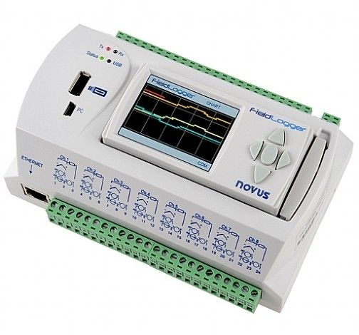

**Figure 2.** Data acquisition unit.

**4 Equations**

Equations should be written by using the “Equation” tool in “Microsoft Word” or by using “MathType”, with 12 pts. font size for full characters. Character font must be “Times New Roman” or “Cambria Math”. Do not write text in the equation editor.

 (1)

$f\left(x\right)=a_{0}+\sum_{n=1}^{∞}{\left(a_{n}\cos{\frac{nπx}{L}}+b_{n}\sin{\frac{nπx}{L}}\right)}$ (2)

Equations must be formatted to be “in-line-text” using indentation of 1cm, with the equation number aligned to the right most of the page width. As in the format of tables and figures, there should be 1 line space between equations and both underlying and overlying paragraphs. The definition of each symbol or parameter in the equation can be given below the equation, after entering 1 line space.

**5 Citations**

You must document whenever you quote, paraphrase, summarize, or use any idea, fact, or figure from source material (unless the material is “common knowledge”). For your manuscript, you should use in-text parenthetical references in conjunction with an alphabetized References list using APA style. In-text citation example can be done as in this sentence (Makino and Beamish, 1998). In the case of more than two authors, et al. should be used after following the first author, e.g. (Dickinson et al., 2005). In technical documents by government agency or institutes, for the first citation, the agency name should be spelled out with the acronym (if it was not done before in the text), such as, (Office of Government Commerce [OGC], 2007), while for the second citation, only the acronym should be used.

In APA style Reference list should be sorted in alphabetical order according to the surname of the first author in an ascending form. Numbering should not be used for references, and there should be no line space between subsequent references. References should be indented with 1 tab stop (use 0.5 cm for tab stop) from the left margin, except the first line of each reference (see the examples below). The references must be given in the text as the author(s) last name and the date in parentheses, such as (Makino and Beamish, 1998).

**References**

Dickinson, M., Cooper, R., McDermott, P. and Eaton, D. (2005). An analysis of construction innovation literature. *Fifth International Postgraduate Research Conference*, April 14-15, Vol. 2, pp. 589-594, Salford, UK.

Hofstede, G., and Hofstede, G. J. (2005). *Cultures and Organizations: Software of the Mind.* McGraw-Hill, New York.

Makino, S. and Beamish, P. W. (1998). Performance and survival of international joint ventures with non-conventional ownership structures. *Journal of International Business Studies,* Vol. 29, pp. 797-818.

Office of Government Commerce (2007). *Project procurement lifecycle: The integrated process*. London, UK: OGC Printing Office.

Schneeweiss, H. and Komlos, J. (2008). *Probabilistic rounding and Sheppard’s correction*. Report No: 045, Department of Statistics, University of Munich, Munich, Germany.